MORSE CODE TRANSLATOR USING TK INTER

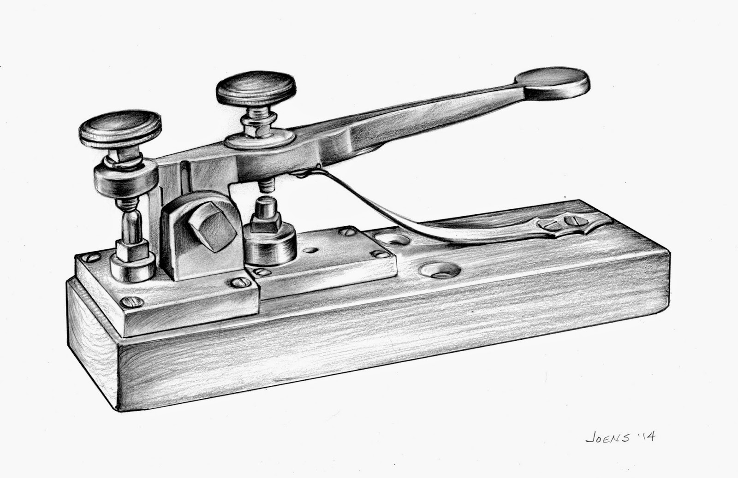

BY- MASUDI SAI HARSHA

CERTIFICATE

CLASS: XIl YEAR: 2021-2022

This is to certify that Investigatory Project is successfully completed by MASUDI SAI HARSHA of Class: XII SCI. Roll no. : 11613102 for the academic year 2021 - 2022 in the School Computer lab.

Head Teacher External Internal Examiner Signature: Examiner (Subject Teacher)

Date: / / 22 Department of: COMPUTER SCIENCE

Principal

Acknowledgement:

I wish to express my deep gratitude and sincere thanks to Principal, MR DHARMENDRA SINGH for his encouragement and for all the facilities that he provided for this project work. I sincerely appreciate this magnanimity by taking me into his fold for which I shall remain indebted to him.
I extend my hearty thanks to Mrs NEETIKA BHARDWAJ my computer science teacher who guided me to successful completion of this project. I take this opportunity to express my deep sense of gratitude to her invaluable guidance, constant encouragement, constructive comments, sympathetic attitude and immerse motivation, which has sustained my efforts at all stages of this project work.
I can’t forget to offer my sincere thanks to my classmates who helped me to carry out this project work successfully and for their valuable advice and support, which I received from them time to time. I also extend a special thanks to my parents for giving me very helpful opinions and suggestions and to all who in some or other way helped me in completing this project.

INDEX
- What is morse code?
- What is python?
- What can python do?
- Why python?
- Introduction to tk inter
- Brief overview of project
- Project code
- Output screenshot
- Future enhancement of project
- Bibliography

WHAT IS MORSE CODE?
- MORSE CODE is a method of transmitting text information as a series of on-off tones, lights, or clicks that can be directly understood by a skilled listener or observer without special equipment . it is named for Samuel F.B.Morse , an inventor of the telegraph.

Algorithm
The algorithm is very simple. Every character in the English language is substituted by a series of ‘dots’ and ‘dashes’ or sometimes just singular ‘dot’ or ‘dash’ and vice versa.
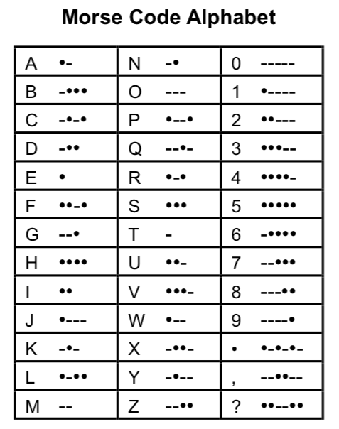

Encryption
- In the case of encryption, we extract each character (if not space) from a word one at a time and match it with its corresponding morse code stored in whichever data structure we have chosen(if you are coding in python, dictionaries can turn out to be very useful in this case)
- Store the morse code in a variable that will contain our encoded string and then we add a space to our string that will contain the result.
- While encoding in morse code we need to add 1 space between every character and 2 consecutive spaces between every word.
- If the character is a space then add another space to the variable containing the result. We repeat this process till we traverse the whole string

Decryption
- In the case of decryption, we start by adding a space at the end of the string to be decoded (this will be explained later).
- Now we keep extracting characters from the string till we are not getting any space.
- As soon as we get a space we look up the corresponding English language character to the extracted sequence of characters (or our morse code) and add it to a variable that will store the result.
- Remember keeping track of the space is the most important part of this decryption process. As soon as we get 2 consecutive spaces we will add another space to our variable containing the decoded string.
- The last space at the end of the string will help us identify the last sequence of morse code characters (since space acts as a check for extracting characters and start decoding them).

Implementation:
Python provides a data structure called a dictionary which stores information in the form of key-value pairs which is very convenient for implementing a cipher such as a morse code. We can save the morse code chart in a dictionary where (key-value pairs) => (English Characters-Morse Code). The plaintext (English characters) takes the place of keys and the ciphertext (Morse code) forms the values of the corresponding keys. The values of keys can be accessed from the dictionary in the same way we access the values of an array through their index and vice versa.

WHAT IS PYTHON?
Python is a popular programming language. It was created by Guido van Rossum, and released in 1991.
It is used for:
- web development (server-side),
- software development,
- mathematics,
- system scripting.

What can Python do?
- Python can be used on a server to create web applications.
- Python can be used alongside software to create workflows.
- Python can connect to database systems. It can also read and modify files.
- Python can be used to handle big data and perform complex mathematics.
- Python can be used for rapid prototyping, or for production-ready software development.

Why Python?
Python is flexible, portable, easy to learn and modifiable language. So, we are Integrating MySQL with python interface for executing any database applications. The various reasons to use python for programming database application are:
- Programming in python is arguably more efficient and faster comparing to the other languages.
- Python is famous for its portability.
- It is plate form-independent.
- Python support SQL cursor.
- In programming application developer needs to take care of the open and closed connections of the database, to avoid further expectation and errors. In python, these connections are taken care of.
- Python works on different platforms (Windows, Mac, Linux, Raspberry Pi, etc).
- Python has a simple syntax similar to the English language.
- Python has syntax that allows developers to write programs with fewer lines than some other programming languages.
- Python runs on an interpreter system, meaning that code can be executed as soon as it is written. This means that prototyping can be very quick.
- Python can be treated in a procedural way, an object-oriented way or a functional way.
INTRODUCTION TO TK INTER
Tkinter is the inbuilt python module that is used to create GUI applications. It is one of the most commonly used modules for creating GUI applications in Python as it is simple and easy to work with. You don’t need to worry about the installation of the Tkinter module separately as it comes with Python already. It gives an object-oriented interface to the Tk GUI toolkit.

Some other Python Libraries available for creating our own GUI applications are
- Kivy
- Python Qt
- wxPython
- Among all Tkinter is most widely used

Tkinter tutorial provides basic and advanced concepts of Python Tkinter. Our Tkinter tutorial is designed for beginners and professionals.
Python provides the standard library Tkinter for creating the graphical user interface for desktop based applications.
Developing desktop based applications with python Tkinter is not a complex task. An empty Tkinter top-level window can be created by using the following steps.
- Import the Tkinter module.
- Create the main application window.
- Add the widgets like labels, buttons, frames, etc. to the window.
- Call the main event loop so that the actions can take place on the user's computer screen.

BRIEFOVERVIEW OF PROJECT…
- The main objective of this python project is to encode and decode morse code language which can save time if it were to be done manually.
- This project is made to be a user friendly .
- User just have to select the language code (encode) and language code(decode) and press convert to get result.
HARDWARE USED:-
- PROCESSOR:- intel core i5
- RAM:- 8GB
- SYSTEM TYPE :- 64bit

SOFTWARE USED:-

macOS Mojave as operating system

python 3.9.0 as front-end and back-end environment

MS word for documentation

PROJECT CODE

#NAME : MASUDI SAI HARSHA
#CLASS: 12
#ROLL NO:
#TOPIC: MORCE CODE CONVERTER
# import all functions from the tkinter
from tkinter import *

# import messagebox class from tkinter
from tkinter import messagebox

# Create a GUI window
root = Tk()

# create a global variables
variable1 = StringVar(root)
variable2 = StringVar(root)

# initialise the variables
variable1.set("lang-code")
variable2.set("lang-code")

'''
VARIABLE KEY
'cipher' -> 'stores the morse translated form of the english string'
'decipher' -> 'stores the english translated form of the morse string'
'citext' -> 'stores morse code of a single character'
'i' -> 'keeps count of the spaces between morse characters'
'message' -> 'stores the string to be encoded or decoded'
'''

# Dictionary representing the morse code chart
MORSE_CODE_DICT = { 'A':'.-', 'B':'-...',
'C':'-.-.', 'D':'-..', 'E':'.',
'F':'..-.', 'G':'--.', 'H':'....',
'I':'..', 'J':'.---', 'K':'-.-',
'L':'.-..', 'M':'--', 'N':'-.',
'O':'---', 'P':'.--.', 'Q':'--.-',
'R':'.-.', 'S':'...', 'T':'-',
'U':'..-', 'V':'...-', 'W':'.--',
'X':'-..-', 'Y':'-.--', 'Z':'--..','a':'.-', 'b':'-...',
'c':'-.-.', 'd':'-..', 'e':'.',
'f':'..-.', 'g':'--.', 'h':'....',
'i':'..', 'j':'.---', 'k':'-.-',
'l':'.-..', 'm':'--', 'n':'-.',
'o':'---', 'p':'.--.', 'q':'--.-',
'r':'.-.', 's':'...', 't':'-',
'u':'..-', 'v':'...-', 'w':'.--',
'x':'-..-', 'y':'-.--', 'z':'--..',
'1':'.----', '2':'..---', '3':'...--',
'4':'....-', '5':'.....', '6':'-....',
'7':'--...', '8':'---..', '9':'----.',
'0':'-----', ', ':'--..--', '.':'.-.-.-',
'?':'..--..', '/':'-..-.', '-':'-....-',
'(':'-.--.', ')':'-.--.-'}

# Function to clear both the text areas
def clearAll() :
# whole content of text area is deleted
language1_field.delete(1.0, END)
language2_field.delete(1.0, END)

# Function to perform conversion from one
# language to another
def convert() :

# get a whole input content from text box
# ignoring \n from the text box content
message = language1_field.get("1.0", "end")[:-1]

# get the content from variable1 and 2, check their values
if variable1.get() == variable2.get() :

# show the error message
messagebox.showerror("Can't Be same Language")
return

elif variable1.get() == "Eng" and variable2.get() == "Morse" :

# function call
rslt = encrypt(message)

elif variable1.get() == "Morse" and variable2.get() == "Eng" :

# function call
rslt = decrypt(message)

else :

# show the error message
messagebox.showerror("please choose valid language code..")
return

# insert content into text area
# from rslt variable
language2_field.insert('end -1 chars', rslt)

# Function to encrypt the string
# according to the morse code chart
def encrypt(message):
cipher = ''
for letter in message:
if letter != ' ':

# Looks up the dictionary and adds the
# corresponding morse code
# along with a space to separate
# morse codes for different characters
cipher += MORSE_CODE_DICT[letter] + ' '
else:
# 1 space indicates different characters
# and 2 indicates different words
cipher += ' '

return cipher

# Function to decrypt the string
# from morse to english
def decrypt(message):

# extra space added at the end to access the
# last morse code
message += ' '

decipher = ''
citext = ''
for letter in message:

# checks for space
if (letter != ' '):

# counter to keep track of space
i = 0

# storing morse code of a single character
citext += letter

# in case of space
else:
# if i = 1 that indicates a new character
i += 1

# if i = 2 that indicates a new word
if i == 2 :

# adding space to separate words
decipher += ' '
else:

# accessing the keys using their values
# (reverse of encryption)
decipher += list(MORSE_CODE_DICT.keys())[
list(MORSE_CODE_DICT .values()).index(citext)]
citext = ''

return decipher

# Driver code
if __name__ == "__main__" :

# Set the background colour of GUI window
root.configure(background = 'royal blue')

# Set the configuration of GUI window (WidthxHeight)
root.geometry("400x350")

# set the name of tkinter GUI window
root.title("Translator")

# Create Welcome to Morse Code Translator label
headlabel = Label(root, text = 'Welcome to Morse Code Translator',
fg = 'black', bg = "light steel blue")

# Create a "One Language " label
label1 = Label(root, text = "One Language ",
fg = 'black', bg = 'pale turquoise')

# Create a "From Language " label
label2 = Label(root, text = "From Language",
fg = 'black', bg = 'gold1')

# Create a "To Language " label
label3 = Label(root, text = "To Language ",
fg = 'black', bg = 'gold1')

# Create a "Converted Language " label
label4 = Label(root, text = "Converted Language ",
fg = 'black', bg = 'pale turquoise')

# grid method is used for placing
# the widgets at respective positions
# in table like structure .
headlabel.grid(row = 0, column = 1)
label1.grid(row = 1, column = 0)
label2.grid(row = 2, column = 0)
label3.grid(row = 3, column = 0)
label4.grid(row = 5, column = 0)

# Create a text area box
# for filling or typing the information.
language1_field = Text(root, height = 5, width = 25,
font = "lucida 13")
language2_field = Text(root, height = 5, width = 25,
font = "lucida 13")

# padx keyword argument used to set padding along x-axis .
language1_field.grid(row = 1, column = 1, padx = 10)
language2_field.grid(row = 5, column = 1, padx = 10)

# list of language codes
languageCode_list = ["Eng", "Morse"]

# create a drop down menu using OptionMenu function
# which takes window name, variable and choices as
# an argument. use * before the name of the list,
# to unpack the values
FromLanguage_option = OptionMenu(root, variable1, *languageCode_list)
ToLanguage_option = OptionMenu(root, variable2, *languageCode_list)

FromLanguage_option.grid(row = 2, column = 1, ipadx = 10)
ToLanguage_option.grid(row = 3, column = 1, ipadx = 10)

# Create a Convert Button and attached
# with convert function
button1 = Button(root, text = "Convert", bg = "red", fg = "black",
command = convert)

button1.grid(row = 4, column = 1)

# Create a Clear Button and attached
# with clearAll function
button2 = Button(root, text = "Clear", bg = "red",
fg = "black", command = clearAll)

button2.grid(row = 6, column = 1)

# Start the GUI
root.mainloop()

OUTPUTS


HOW TO USE THE APP STEP BY STEP

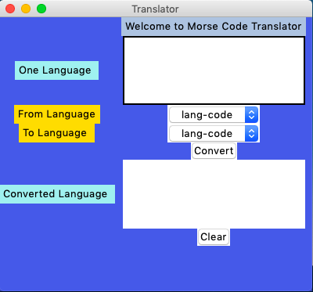
- STEP 1:

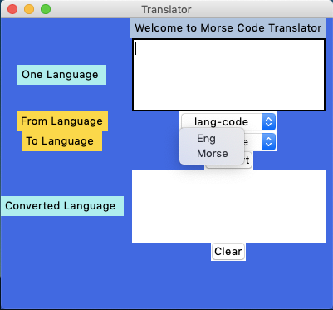
select the from language (English / morse) and repeate the same for to language(English/morse).

- STEP 2:
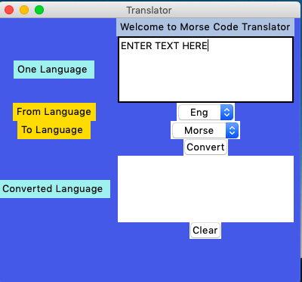
Enter the text in the box you want to convert.

- STEP 3:

After entering the text in the box press convert .

- STEP 4:
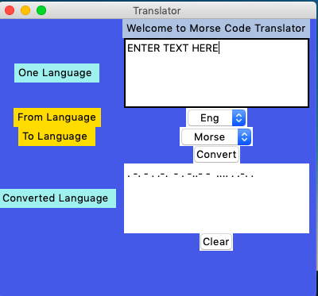
The translation will be displayed in the converted language box.

TRANSLATION OF SOME BASIC EMERGENCY SIGNALS

THE SIGNALS WHICH WE ARE GOING TO TRANSLATE ARE:
- SOS
- CDQ
- MAYDAY
- PANPAN

TRANSLATION OF SOME OTHER WORDS AND SENTENCES

THE WORDS AND SENTENCES WE ARE GOING TO TRANSLATE ARE:
- HI
- HELLO
- PYTHON
- HI MY NAME IS MASUDI SAI HARSHA
- TKinter
- PROJECT
- MORSE CODE
- TRANSLATOR

SOS

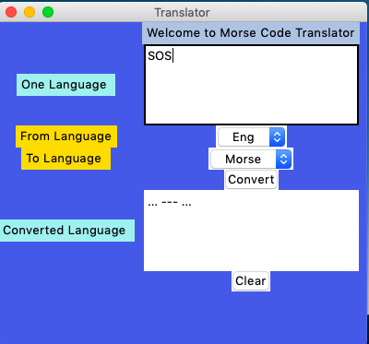
SOS:-SAVE OUR SHIP

CDQ

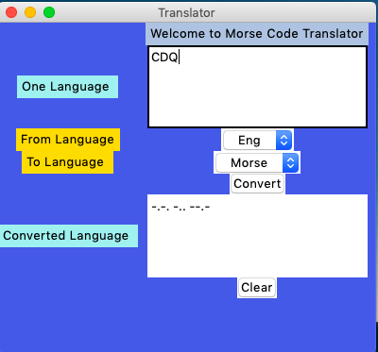
CDQ:-COME DANGER QUICK

MAYDAY

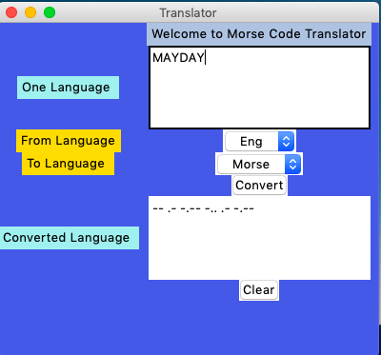

PANPAN

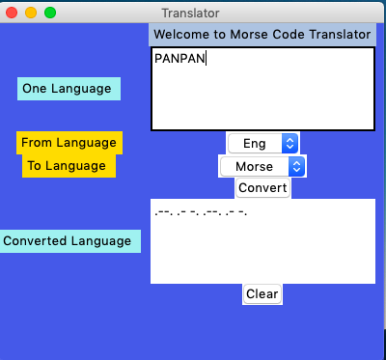

HI

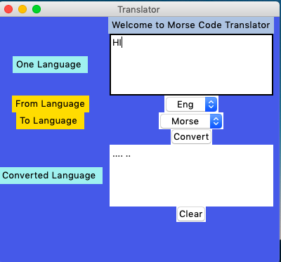

HELLO

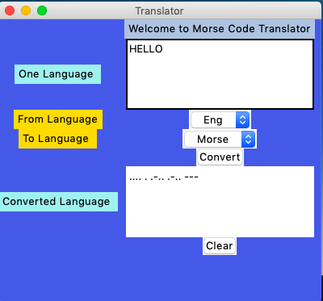

PYTHON

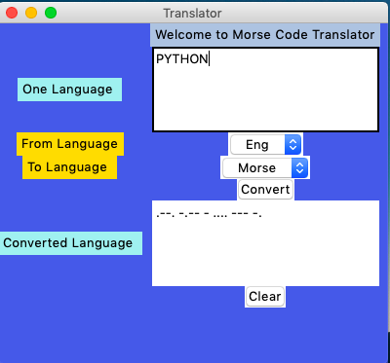

HI MY NAME IS MASUDI SAI HARSHA

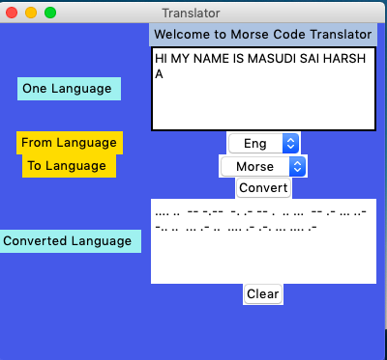

TKinter

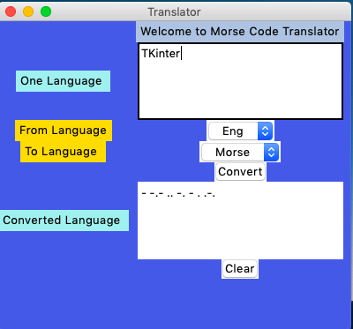

PROJECT

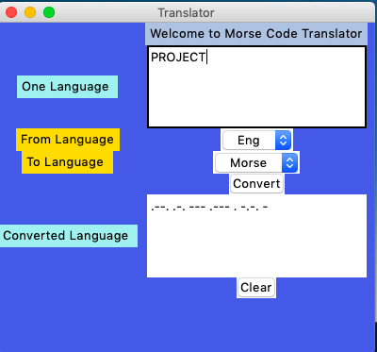

MORSE CODE

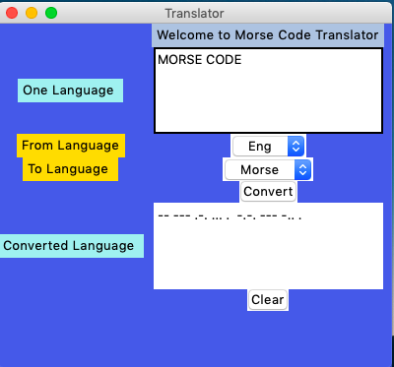

TRANSLATOR

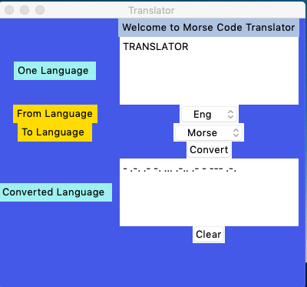

FUTURE SCOPE
- Improve user interface
- Connecting the flashlight/torch of the device to emit the code
- Add more language code
- Add voice recognition for live translation

BIBLIOGRAPHY
- Computer science with python by sumita aroura
- geeksforgeeks.org
- youtube channel freecodecamp.org
- sites.google.com



